WRMISS 2025 – First Information / June 2025

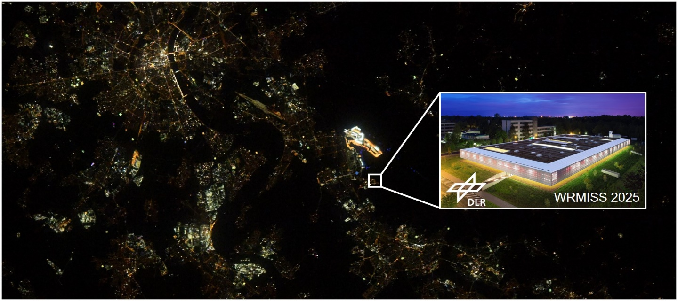

The **WRMISS 2025** will be hosted inside the **:enivhab** facility of the Institute of Aerospace Medicine <https://www.dlr.de/en/me/> at DLR in Cologne from **Tuesday 02nd to Thursday 04th September 2025**.

<https://www.dlr.de/en/dlr/locations-and-offices/cologne>

This is indicated in the picture above where you see a picture of “Cologne at night” as taken by ESA astronaut Alexander Gerst from the International Space Station (ISS) and the location of the **:envihab** at DLR. The Cologne city center with the cathedral is shown in the upper left part of the picture

* Getting to the DLR site in Cologne

For those of you who have not been at DLR in Cologne. The DLR site Cologne is situated in the south of Cologne.

<https://www.dlr.de/en/dlr/locations-and-offices/cologne/getting-there>

For those of you who want to stay at hotels in the city center you can reach DLR by taking the S-Bahn from Cologne main train station (19-minute ride with S19 and/or S12) to Porz-Wahn.

We will provide means of transport (bus) from the S-Bahn station Porz-Wahn to DLR (at dedicated times in the morning) and provide means of getting you back to the S-Bahn station in the afternoon.

**Important information for hotels in the Cologne city center:** If you want to stay in the city center (close to the main train station) please book your hotels as soon as possible. Cologne will be full in September (not only tourists, but also due to fairs in Cologne).

* Hotel close to the DLR site in Cologne

**REPEAT Hotel KÖLN AIRPORT**

We have reserved a room contingent at the **REPEAT Hotel KÖLN AIRPORT** <https://www.andrepeatkoeln.de/en> which will guarantee you a room from **Monday 01st to Friday 05th** September 2025 with a total room rate (including breakfast) of:

**€ 121.00 + €5.45** (“promotion of the arts in Cologne”)

For booking the room at this rate please consider the following:

* Please send your request for reservation to:

[reservation.cgn01@bmine.de](mailto:reservation.cgn01@bmine.de) or [event.cgn01@bmine.de](mailto:event.cgn01@bmine.de)

* Use the code: **WRMISS2025** in the header for the reservation
* Please include: [thomas.berger@dlr.de](mailto:thomas.berger@dlr.de) and [guenther.reitz@dlr.de](mailto:guenther.reitz@dlr.de) in cc for your reservation so that we can keep track of the number of rooms reserved
* The hotel will ask for a credit card number to confirm the reservation

**IMPORTANT NOTICE:** Please reserve your rooms till the July 10th 2025. After this date the rooms will no longer be available. You can cancel your reservation free of charge up to one week before arrival.

We will organize transport to and from the hotel in the morning and in the afternoons. The hotel is around a 10 minute walk to the DLR entrance + within DLR you would have to walk for another 10 minutes to reach the **:envihab**.

<https://www.dlr.de/en/dlr/locations-and-offices/cologne>

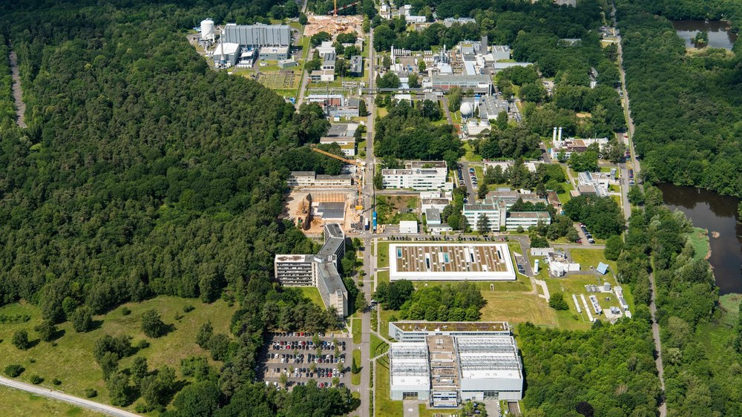

DLR Entrance

:envihab

* Hotel close to the train station in Porz-Wahn

We will have additional rooms at the:

**LOGINN HOTEL COLOGNE AIRPORT**

<https://achat-hotels.com/en/hotels/cologne-airport-loginn>

which is located 500 meters from the train station in Porz-Wahn (**19-minute S-Bahn (S19 and/or S12) ride to the City Center** **– Main Train Station**).

We have reserved a room contingent at the **LOGINN HOTEL COLOGNE AIRPORT** which will guarantee you a room from **Monday 01st to Friday 05th** September 2025 with a total room rate (including breakfast) of:

**€ 105.00 + €4.90** (“promotion of the arts in Cologne”)

For booking the room at this rate please consider the following:

* Please send your request for reservation to:

[LOGINN-Koeln@achat-hotels.com](mailto:LOGINN-Koeln@achat-hotels.com)

* Use the code: **Reservierung Nummer: 7100/1 WRMISS_DLR** in the header for the reservation
* Please include: [thomas.berger@dlr.de](mailto:thomas.berger@dlr.de) and [guenther.reitz@dlr.de](mailto:guenther.reitz@dlr.de) in cc for your reservation so that we can keep track of the number of rooms reserved

**IMPORTANT NOTICE:** Please reserve your rooms till the July 10th 2025. After this date the rooms will no longer be available. You can cancel your reservation free of charge up to 45 days before arrival.

* Transport to DLR

As mentioned we will organize a bus which will stop i) at the train station at Porz-Wahn (LOGINN Hotel) followed by ii) REPEAT Hotel and iii) DLR. This will travel in the morning to DLR and will travel at the end of each day from DLR to i) REPEATH Hotel and ii) train station at Porz-Wahn (LOGINN Hote